# CS 255 System Design Document Template

This template lays out all the different sections that you need to complete for Project Two. Each section has guidance to prompt your thinking. You will need to continually reference the interview transcript as you work to make sure that you are addressing your client’s needs. There is no required length for the final document. Instead the goal is to complete each section based on what your client’s needs are. Remove this note when you are finished, and replace all bracketed text with the relevant information.

## UML Diagrams

### UML Use Case Diagram

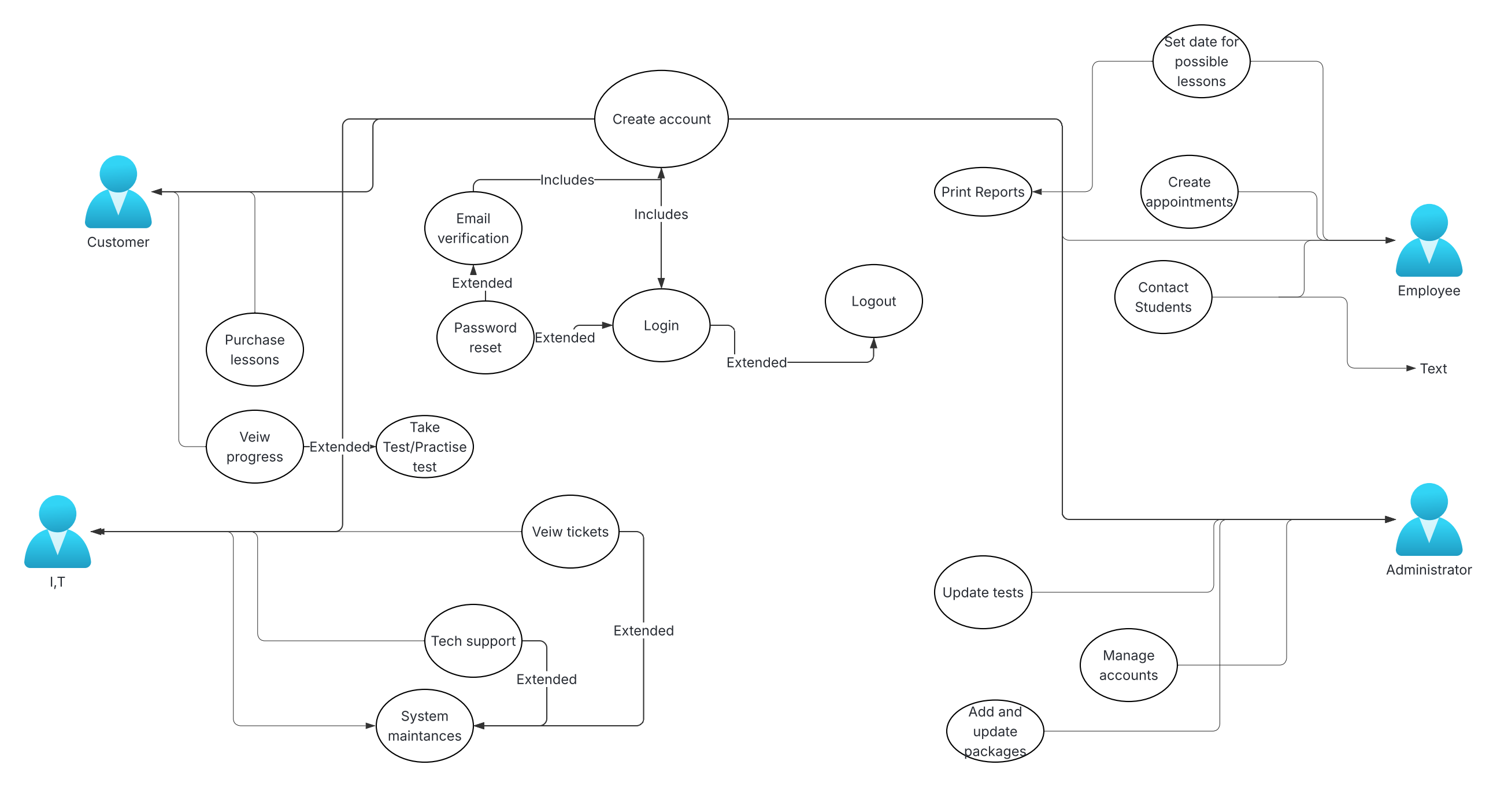

### UML Activity Diagrams

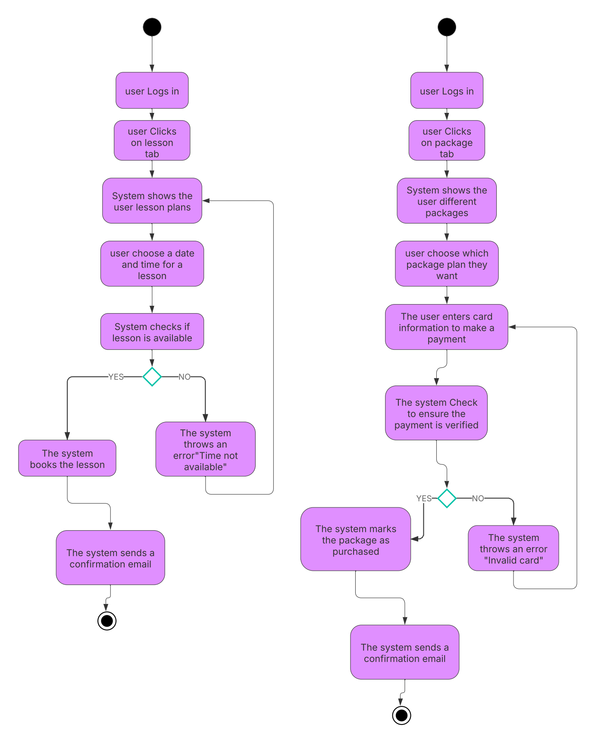

### UML Sequence Diagram

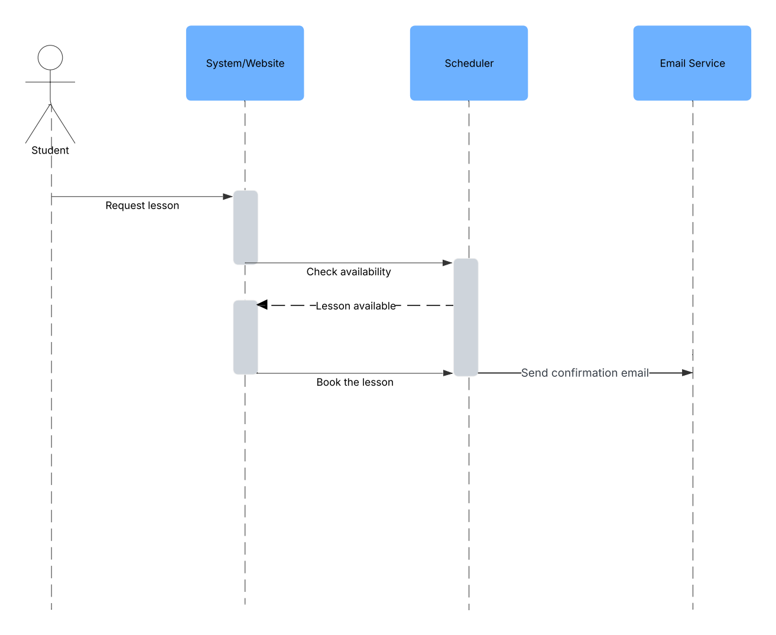

### UML Class Diagram

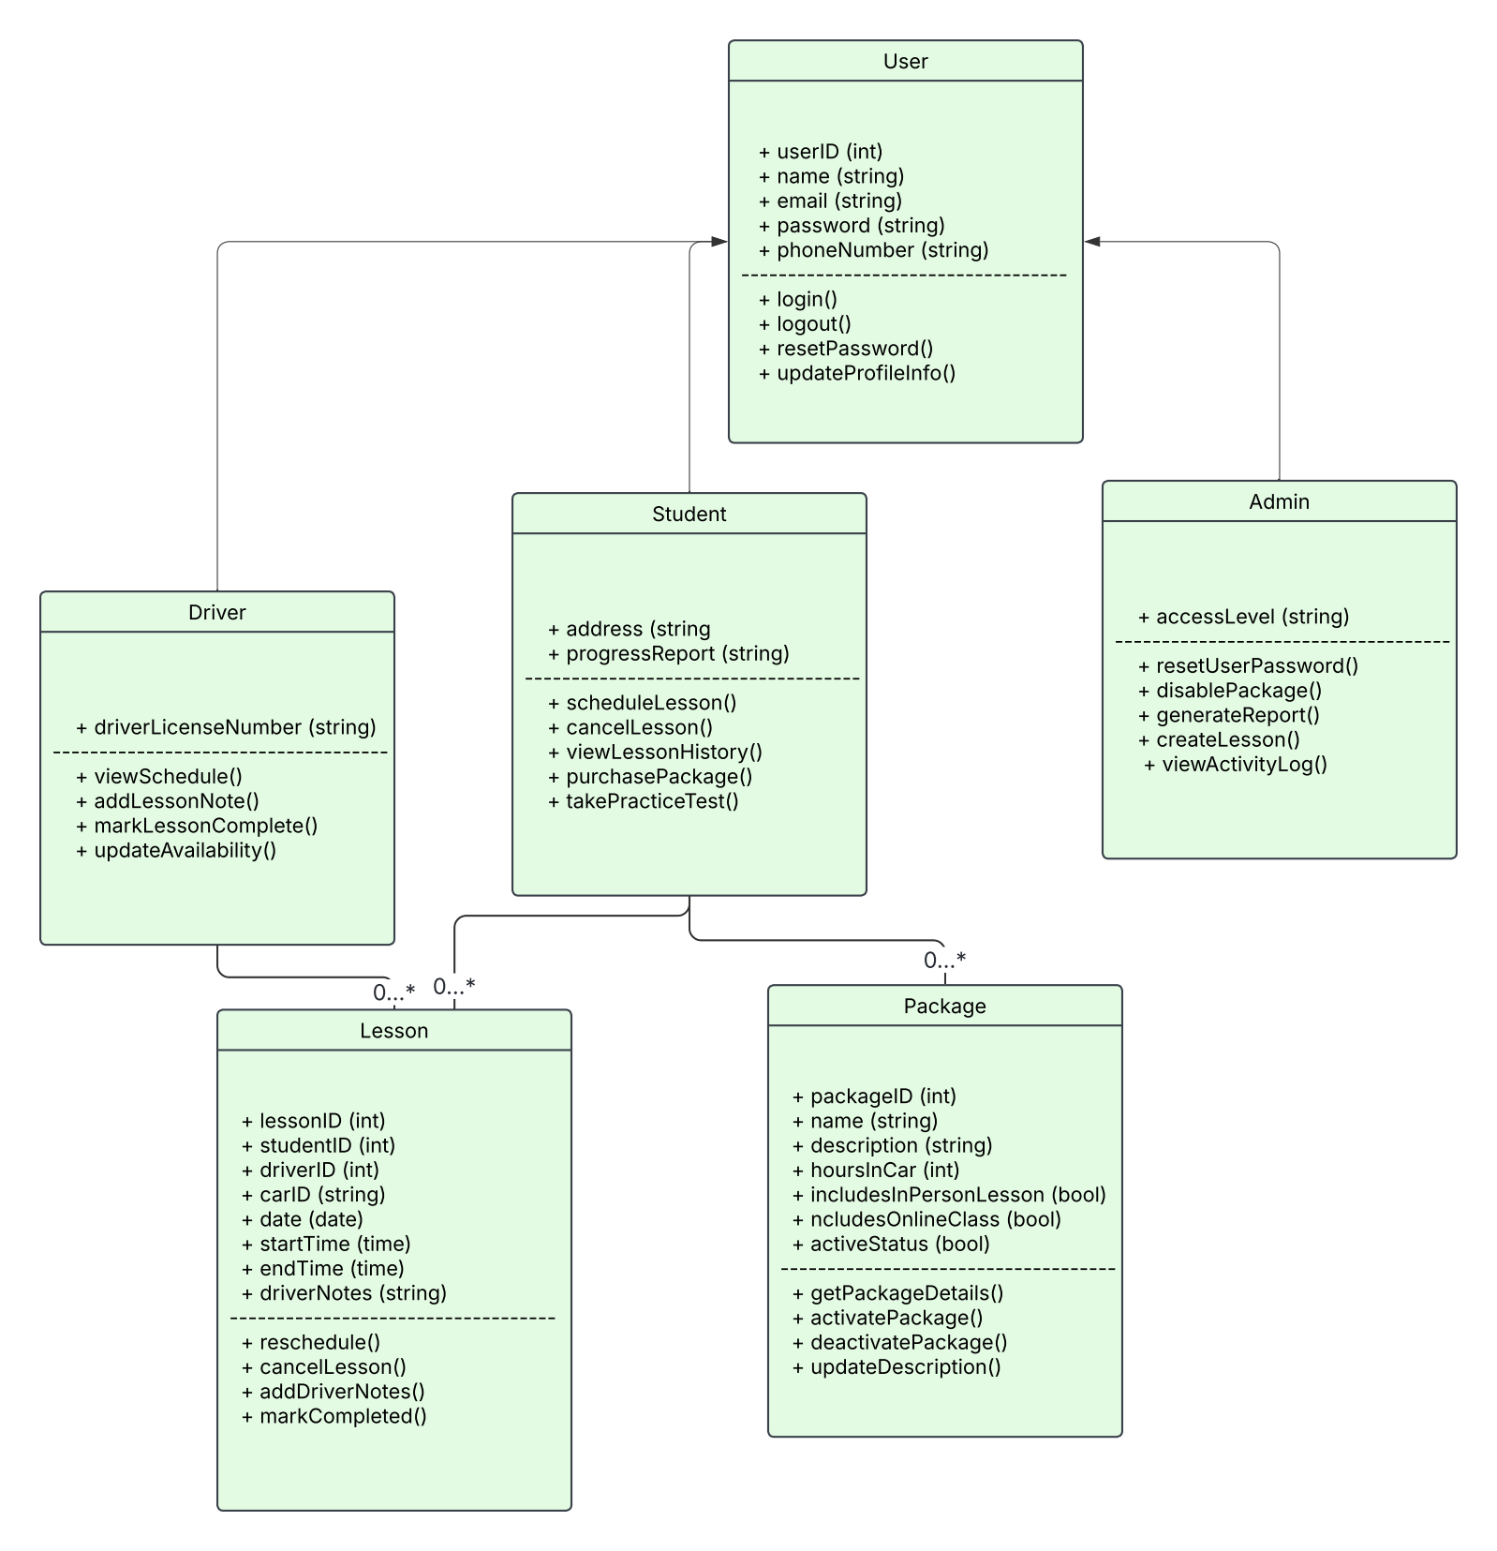

## Technical Requirements

*The driver path system will be a cloud-based web application. This system is designed to support students, instructors, along with administrative staff in the managing of driving lessons, both online and in person, packages, and the various account functions associated with instructors, students, and administration. This will lead to some technical requirements that we will have to consider in order for this program to function correctly.*

*Technical Requirements*

* *Utilize a cloud service to host the system and allow for additional security and scalability.*
* *The backend of the website can be created with a programming language such as Python. The front end of the website can be created with HTML and or JavaScript.*
* *Using a database language like MySQL, we can create a database so we can safely and securely store all the information for each users, be it a student, teacher, or admin.*
* *For security, ensure that all information is encrypted using end-to-end encryption and ensure that each role on the website, such as instructor, student, or admin, each only having access to what is necessary for someone of their position.*
* *The system should be programmed to function on most web browsers, and with the consideration of an Android and iOS mobile version.*